How to Setup User Access to Quant Reports

In order for a user to access Quant Reports in IimDirect, they must be setup in three places:
- As a member of the active directory group AS-QuantReports-Users
- Added to the appropriate role in the admin section of IimDirect
- Setup as a user in QER database

Steps 1 and 2 will allow a user to be able to load EquityDirect in their browser and the Quant Reports menu item will be visible. Step 3 is to grant a user access to specific strategies within Quant Reports. By default, a user does not have access to any strategies.

The QER tables we will discuss are:
access_strategy
access_group_def
access_group_makeup
access_user

The first thing to check is whether a user exists in the access_user table:
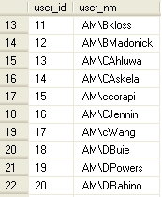

If not, insert into the table:
insert access_user (user_nm) select 'IAM\JLouh'

Let’s look at the access_strategy table, which maps strategies to users or groups of users:
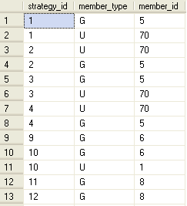

The numbers in the strategy_id column join with strategy_id in the strategy table. Under the member_type column, there can be two values: G or U. G stands for group and U stands for user. From the screenshot, we can see that strategy 1 can be accessed by group 5 or user 70.

If you check the access_user table, you can determine who user 70 is:
select * from access_user where user_id = 70
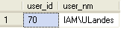

And to check which group is number 5:
select * from access_group_def
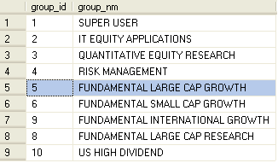

To find out the members of group 5:
select * from access_group_makeup where group_id = 5
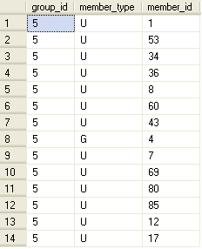

Notice that group 5 consists of users and a group. It is important to note that groups can be nested.

Groups and nesting may seem overly complex at first glance but it allows users to very easily be setup with the same access as his/her team. One-off access can be accomplished by mapping an individual user directly to a strategy. A combination of adding a user to a group and adding them to specific strategies can also be done.

Side note: There is no limit to how deeply groups can be nested.

To conclude the initial example, we could do this to map the user directly to strategy 1:
declare @user_id int

select @user_id = user_id
from access_user
where user_id = 'IAM\JLouh'

insert access_strategy (1, 'U', @user_id)

Or we could add the user to an existing group that already has access to strategy 1:
insert access_group_makeup
select 5, 'U', @user_id

Obviously, if we added the new user to an existing group, the user would also gain access to all strategies the group already has access to. So it is always a good idea to check whether a user needs one-off access to a strategy or if they should have the same access as an existing team or some combination of both.
Conceptual Diagram:
